APPLICATION FOR SCIENTIFIC STUDY IN BAXTER STATE PARK
Category 1 Research Request
1. TITLE: Appalachian Trail Visitor Impact Assessments to Enhance Sustainability and Improve Visitor Experiences

2. NAME OF RESEARCHER: Dr. Jeffrey L. Marion, USDI, U.S. Geological Survey, jmarion@vt.edu, 540-231-6603. Address: Virginia Tech, 310 W. Campus Dr., Blacksburg, VA 24061.

3. RESEARCHER’S CREDENTIALS: I am a recreation ecologist – I specialize on visitor impacts to protected natural areas. Please see my USGS website for a listing of publications: : https://profile.usgs.gov/jeff_marion

4. BENEFITS TO BE DERIVED FROM RESEARCH:
This research is funded by the USDI National Park Service, Appalachian Trail Park Office, our study’s Project Objectives are to:
1. Provide quantitative, spatially related, baseline documentation of the Appalachian Trail and recreation sites (overnight camping and day-use) to characterize the type, areal extent, and severity of visitation-related resource impacts to vegetation and soils,
2. Statistically analyze data to evaluate trail design and alignment attributes and recreation site geophysical attributes to develop sustainability models, ratings, and guidance,
3. Conduct analyses of tread and site data to identify and describe the relative influence of key use-related, environmental, and managerial factors that can be manipulated through design and management actions to minimize resource impacts,
4. Assess visitor impacts to sensitive vegetation communities and species and the sustainability of the A.T. tread to climate change, particularly to extreme weather and precipitation events,
5. Conduct spatial statistical analyses to evaluate how trail and site conditions and design attributes vary across latitude, elevation, eco regions, soil types, and management jurisdictions/styles,
6. Formulate Best Management Practices describing actions (educational/interpretive, regulatory, and site/facility management) that avoid or minimize visitation and climate change related resource impacts,
7. Apply sustainable trail and recreational facility construction and design principles through workshops with ATC field staff and volunteer trail maintainers, and
8. Develop and communicate refined Leave No Trace practices and outdoor ethics through pamphlets, signs, online/digital media, and teaching curricula. Implement new outreach activities to deliver these products using field-based A.T. staff, websites, social media, and classroom teachers.

5. DETAILED DESCRIPTION OF RESEARCH: I’ve attached a Study Plan that contains more comprehensive information but here’s a more concise overview: This is a multi-phase project expected to be funded over three years, year one includes the states of Maine, New Hampshire, Vermont, Massachusetts, and Connecticut. It proposes to perform trail and day/overnight recreation site condition and sustainability assessments along approximately a 10% sample of the Appalachian Trail, with analyses conducted to guide the development of effective Best Management Practices. For each year, we will select approximately 25 5-kilometer segments within which all measurements will be taken. Within each 5k sampled segment we will perform trail condition assessments at approximately 50 sample points and trail transect. The sampling will be performed by two teams of 2-3 field staff who will access the trail by foot. All measurements are non-destructive and do not require site alteration, plant or soil specimens, or waivers of park rules. Campsites and informal (visitor-created) trails within each 5k segment will also be assessed, again with non-destructive assessments and no disruptions to the visiting public.
Analysis generated from this project will be applied to improve the sustainability and safety of trail alignments, selecting impact-resistant camping and day-use sites, better manage visitor use, and interpret the results to land management partners and the visiting public. A core research focus is to improve the sustainability of trail alignments and recreation site designs to reduce park operating costs and mitigate climate change related impacts associated with extreme weather events. Staff will utilize these findings in revising the park Comprehensive Plan, addressing carrying capacity issues, identified safety deficiencies, and in managing group, commercial, and special event uses that require analysis to address resource protection decisions.

6. AREA(S) OF THE PARK FOR THE RESEARCH: See Google Earth image of the sampled 5k section of the Appalachian Trail within Baxter State Park.
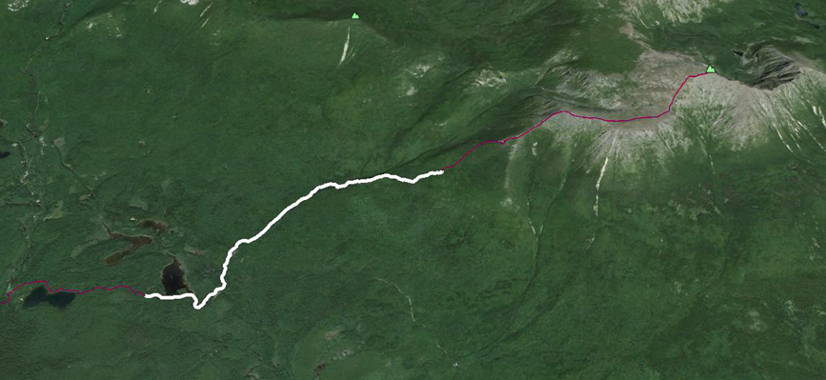

7. IMPACT ON THE PARK: No negative impact, positive impact in that we will share our data from the park and all publications resulting from this study.

8. BUDGET: Funded by USDI, National Park Service- no funding or assistance is needed from Baxter SP.

9. TIMETABLE FOR RESEARCH AND COMPLETION OF APPLICATION: (USE ADDITIONAL SHEET[S]
The fieldwork will be conducted by a staff of 2-3 in late-July to early August and will require 1-2 days to complete. The research project for the northern portion of the A.T. will run two years but the ending date for the entire study is 2/15/2017. DATE: Submitted 3/16/2015

